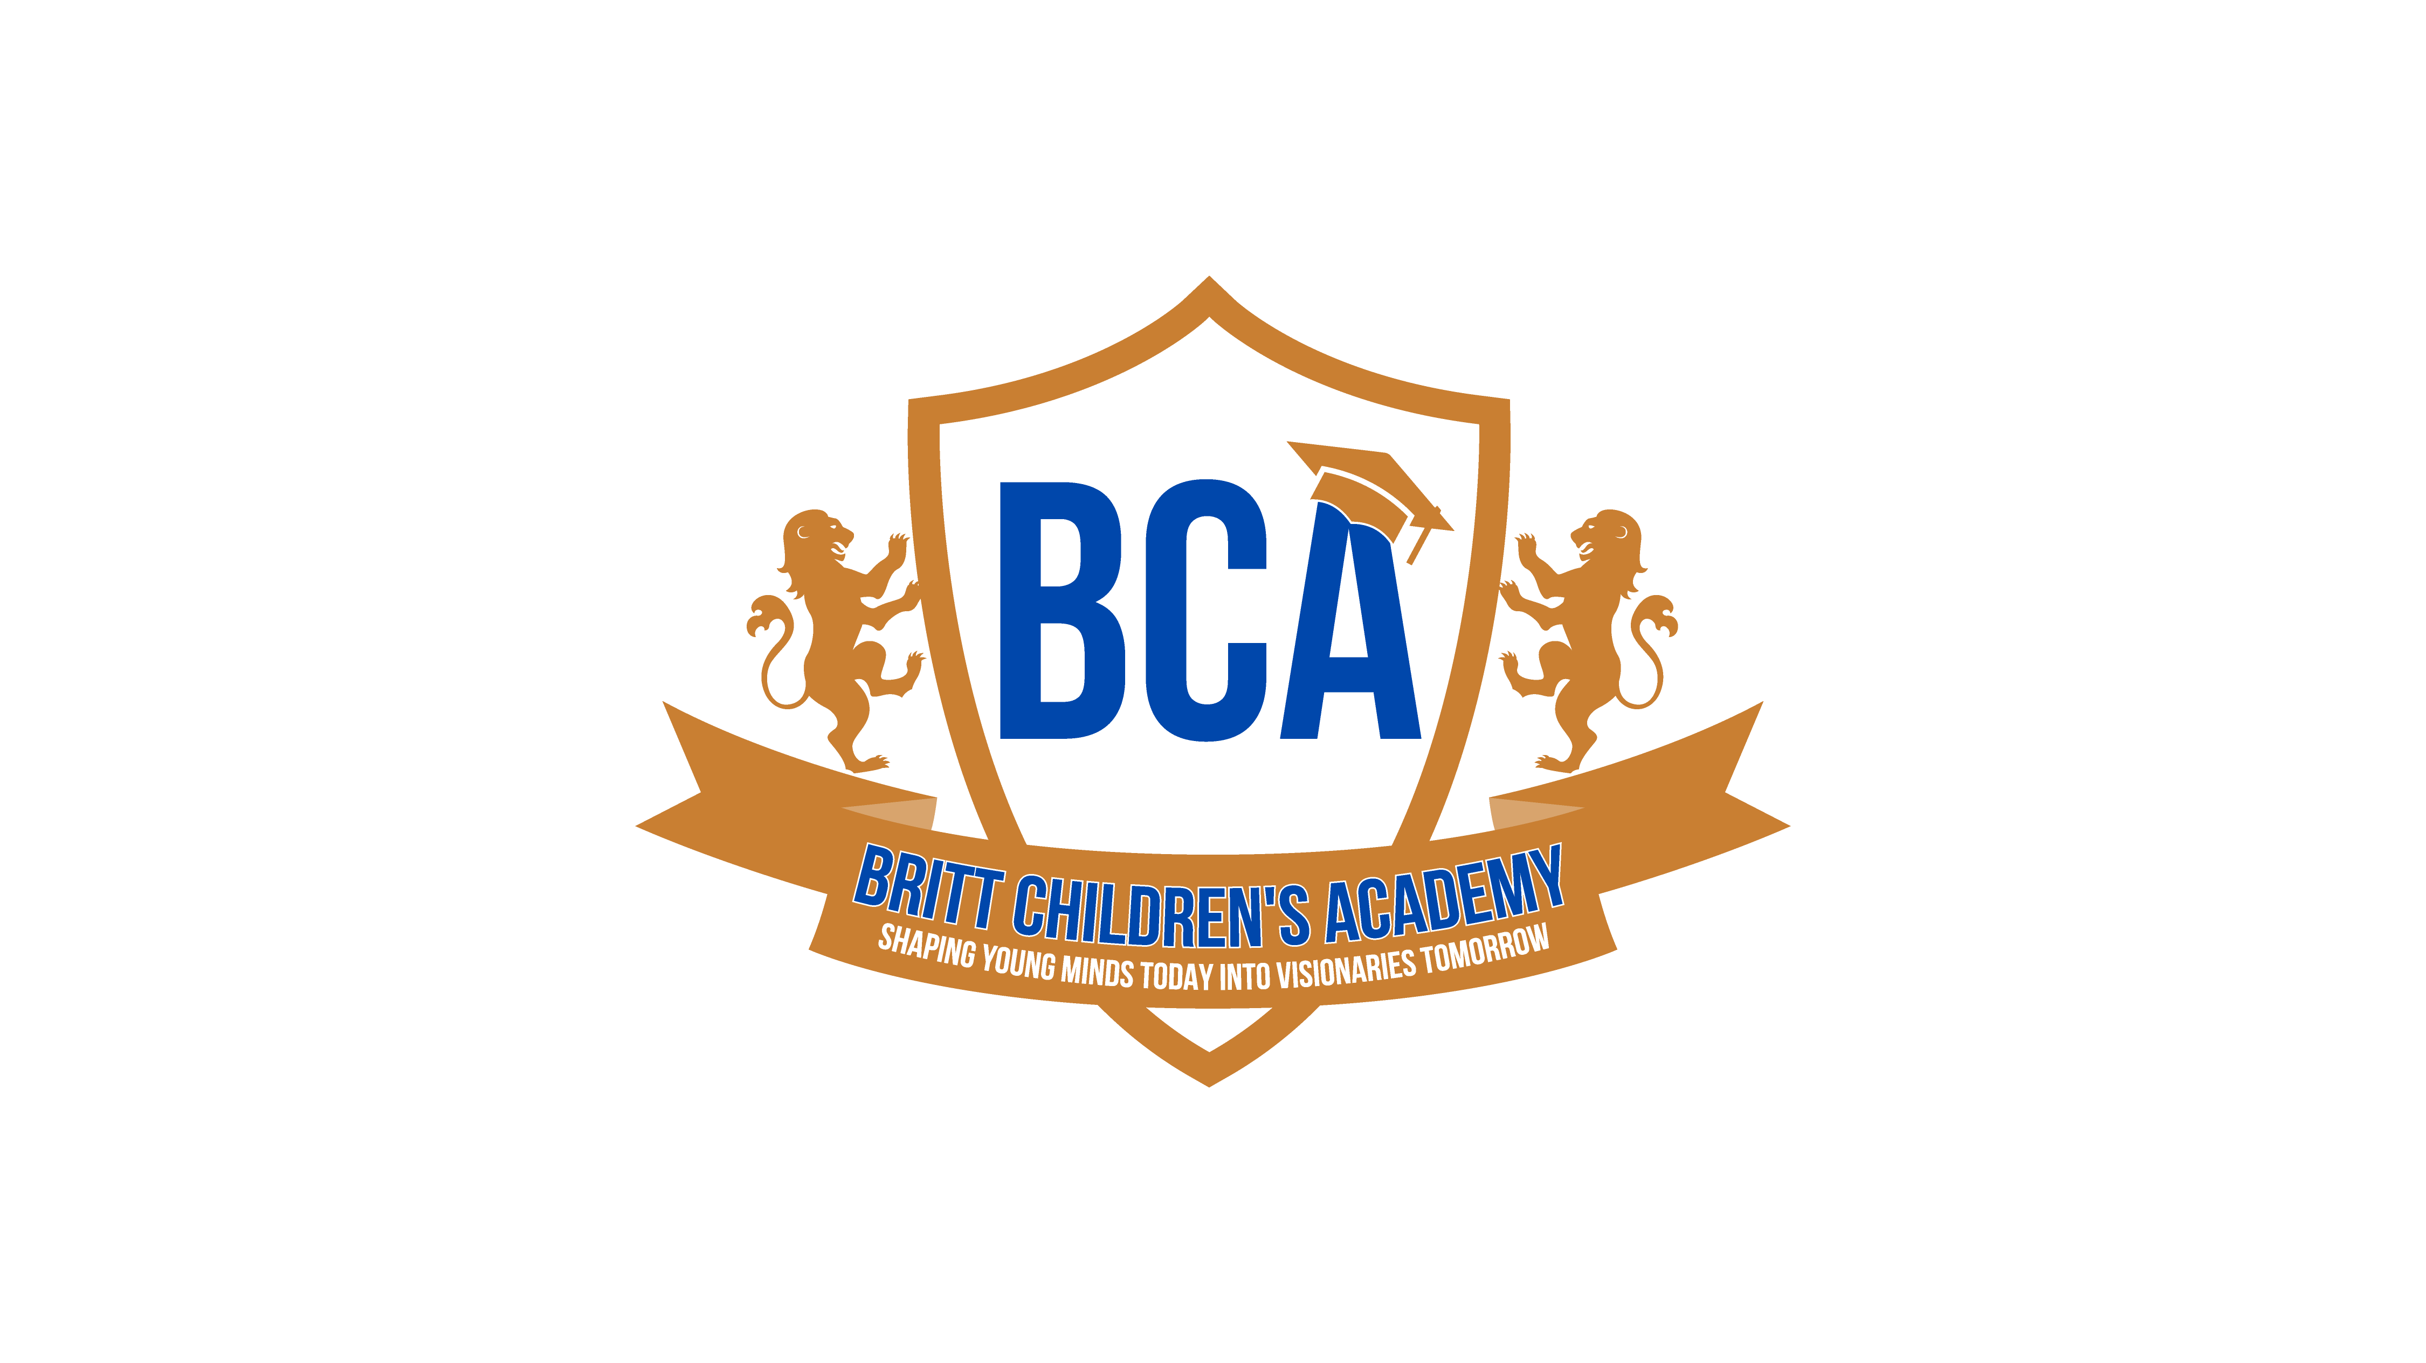

Britt Children’s Academy

Parent Handbook – School Year 2025–2026

Welcome to Britt Children’s Academy!
Welcome to Britt Children’s Academy! We are so excited to welcome you into our family! It is an honor for us to be able to have a small role in your child(ren) early education and we do not take this opportunity lightly.
We recognize the importance of a quality early childhood program and have made it our business to continuously exceed our benchmarks by hiring the best teachers, implementing innovative teaching methods with enriching activities that are aimed at developing the whole child.
Please read this handbook to acquaint yourself with our policies and procedures. Sign and return the back page indicating that you have read it in its entirety and agree to the following policies.
Thank you for choosing our school! We look forward to partnering with your family to ensure the best results for your child.
“Free the child’s potential and you will transform him into the world”
~Maria Montessori

The BCA Morning Pledge
We say this pledge daily to inspire confidence, pride, and community:
When I come to BCA…
- I am an author
- I am a leader
- I am a scholar
- I am an explorer
- I am a creator
- I am a thinker
I AM IMPORTANT! I AM IMPORTANT! I AM IMPORTANT!
We are all important and special, and we never let anyone tell us differently.

Tuition & Fees

Weekly Tuition
- Tuition is due every Monday morning.
- A $50 late fee (per child) will be added if payment is late. Fees will not be waived.

Payment Requirements
- Every family must enroll in autopay through Brightwheel OR pay 2 weeks in advance.
- Attendance will be suspended after 2 weeks of non-payment.
- Continued non-payment may result in unenrollment.
- Parents paid biweekly must stay 2 weeks ahead.

Payment Methods
- Brightwheel (debit/credit)
- Checks accepted at the center (bounced check fee: $35)
- Cash accepted (not preferred)

Additional Fees
- Registration Fee: $85 yearly (July 1st)
  - Additional $50 for families with multiple children
- Returned Brightwheel payment fee: $35 each occurrence
- All tuition/fees must be paid before the first day of attendance.
- Tax records are available in the Brightwheel app.
All tuition and fees are subject to change without prior notice.

Vacation Policy
BCA is closed for two weeks each calendar year:
- Summer Break: Last week of July
- Christmas Break: Week of Christmas
Parents do not pay for these two weeks.

Vacation Week Substitution Option
We understand that families may wish to take vacation at different times during the year. For this reason, each family may substitute one of the scheduled closure weeks for a different week of their choice.
Please note:
- When substituting, the family will not pay for the week they choose (their personal vacation week).
- The substituted scheduled closure week then becomes a regular tuition week, and tuition must be paid for that week.
Example:
If a family wants to take a vacation during Spring Break, they may substitute it for their Summer Break week.
- Spring Break: No tuition due
- Summer Break: Tuition is due

Absences
- Tuition is still required when your child is absent — no exceptions.
- If a child is absent due to illness for more than 2 weeks, they will be withdrawn to avoid additional charges.
- Either party (parent or BCA) may terminate enrollment with a one-week written notice.
- Weeks are not prorated for holidays.

ELC Parents
- Co-payments are due every Monday.
- Absences:
  - 10 days allowed by the coalition
  - 3 excused (no note required)
  - 7 unexcused (note required)

Parent Rate Differences
Parents are responsible for the difference between the ELC reimbursement and BCA’s rates.

Example:
- Parent co-pay: $5/week
- ELC pays: $130/week
- BCA rate: $200/week
- Parent pays: $75/week

Notes for Absences
- Doctor’s note required for illness absences (otherwise a Mommy Note is used).

Drop-Off & Pick-Up Procedures

Hours of Operation:
6:30 AM – 6:00 PM
- Students must be dropped off no later than 9:00 AM.
- Notify the director ahead of time for appointments.
- Children arriving after 9 AM without prior approval will not be admitted.

Late Pickup Fees
- Late at 6:01 PM.
- $50 per child, plus $15 every additional 15 minutes.
- Must be paid in cash the next morning otherwise children will not be allowed to attend; no exceptions.

Brightwheel App
All families must use the Brightwheel app for:
- Sign-in/sign-out
- Communication
- Payments
- Notifications
- Check the app daily for updates.

Important Points
- Only authorized adults with Brightwheel access may pick up.
- Siblings must be 18+ to pick up.
- A government ID is required for all pickups.
- Parents must ensure all approved adults have downloaded the app.
- A front desk tablet is available if you have phone issues.
Do not leave your child without confirming they are checked in.

Parent Notification
All communication — including updates, events, and policy changes — will be sent through Brightwheel. Parents must check the app regularly.

Suspension Policy
Students may be suspended for behaviors that compromise safety, including:
- Biting
- Hitting
- Aggressive or disruptive behaviors

Consequences
- 1st Offense: Parent Notification
- 2nd Offense: 2-day suspension
- 3rd Offense: Expulsion from the program
After-school students suspended from their elementary school cannot attend BCA during regular school hours.

Mealtime Policies
- BCA provides: breakfast, lunch, and snack.
- Breakfast ends at 8:00 AM — children must arrive by 7:45 AM.
- BCA is a PEANUT-FREE facility.
- Children with food allergies must bring their own meals.
- Outside food requiring refrigeration must include an ice pack — we do not refrigerate student food.
- No candy.
- Label all lunch containers.

Required Records
- Updated immunizations and physicals are required.
- Parents who opt out of vaccines must provide a valid waiver.
- Students cannot attend without updated documentation.

Potty Training
- Begins in the 2-year-old class.
- Pull-Ups with Velcro sides only.
- No diapers for potty-training students.
- Elastic-waist clothing encouraged.
- Training is a parent–teacher partnership.

Dress Code (Uniform Required)
Uniforms are mandatory at BCA.

Shirts
- Polo shirts from The Children’s Place (all colors except yellow/orange)
- Must be embroidered with BCA logo at Brevard Team Sports

Bottoms
- Solid color navy or khaki
- No leggings, denim, patterns, or color blends.

Shoes
- Closed-toe athletic shoes only
- No crocs, sandals, or slip-ons

Accessories
- Only earrings allowed
- BCA is not responsible for lost/damaged jewelry

Uniform Compliance
- All students must wear full uniform daily
- Students not in uniform cannot attend
- New students get a 1-month grace period to purchase uniforms and have logo added.

Brevard Team Sports
- Phone: (321) 639-8326
- Address: 606 S. Cocoa Blvd, Cocoa, FL 32922

Sickness Policy
If your child becomes ill:
- You will be notified for immediate pickup.
- Child must be picked up within 1.5 hours.

Return Requirements
- Fever, vomiting, and other listed illnesses require:
  - 24 hours symptom-free, AND
  - A doctor’s note
- Children with head lice must remain home 48 hours, complete treatment, and return lice-free.

General Illness Symptoms (not limited to):
- Fever or vomiting
- Sore throat with fever
- Rapid breathing
- Rash with fever
- Diarrhea
- Continuous severe cough
- Ear/eye discharge
- Yellow/green mucus
- Open skin lesions
BCA reserves the right to determine whether a child must go home and when they return. Some illnesses are highly contagious and regardless of a doctor’s note we reserve the right to require a child to remain at home until symptoms have lessened.

Medication Policy
- Only prescription medication is administered.
- Must be in original packaging and labeled.
- Parents must complete an Authorization for Medication form.
- Parents must inform staff of any medication administered at home.

Discipline Policy
BCA uses positive reinforcement and redirection.
We do not use:
- Physical punishment
- Food-related discipline
- Humiliating or frightening discipline
We encourage students to:
- Respect others
- Keep hands/feet to themselves
- Follow directions
- Use materials properly
- Treat others with kindness

If problematic behavior occurs:
- Parent called to speak with child
- Parent may be required to pick up child
- Physical confrontation = consequences:
  - 1st offense: 1-day suspension
  - 2nd offense: dismissal

Extras & Daily Items
Please label all items, including diapers and Pull-Ups.
- Sheets and blankets go home every Friday for cleaning.
- One sippy cup required for 1-year-olds (kept at the center).
- NO pacifiers.

Birthdays at BCA
To celebrate at school:
- Notify the Director one week in advance
- Store-bought items only
- Cupcakes must arrive by 2 PM (one for every child in the center)
- No whole cakes, pull-apart cakes, or ice cream cakes
- Goodie bag items must be packaged and unopened
- No peanuts
- Families cannot attend; pictures will be posted on Brightwheel

First Day Checklist

All Students
- Brightwheel app downloaded
- Registration packet completed
- Food program application submitted
- Registration fee + first tuition payment
- Labeled crib sheet
- Labeled blanket
- Kinder sleep mat
- One full change of labeled clothing (including socks)

Toddlers
- Labeled sippy cup
- Labeled diapers
- Labeled Pull-Ups (Velcro sides only)
- Three full changes of labeled clothing

Thank You!
We are thrilled to partner with you for a successful and joyful school year at Britt Children’s Academy!

